**Reading Response – “The Very Hungry Caterpillar?” by Eric Carle**

In the book, “**The Very Hungry Caterpillar?**” by **Eric Carle**, the caterpillar in the book eats through different types of food each day!

1. Write the names of some of the foods that the very hungry caterpillar ate through in the book.

_____________________________________ _____________________________________

_____________________________________

_____________________________________

_____________________________________

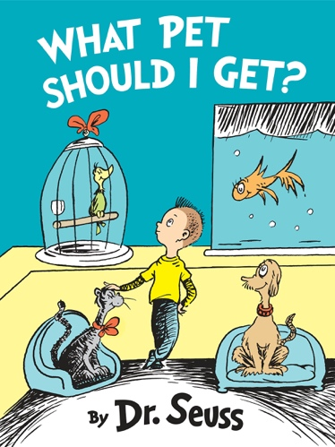

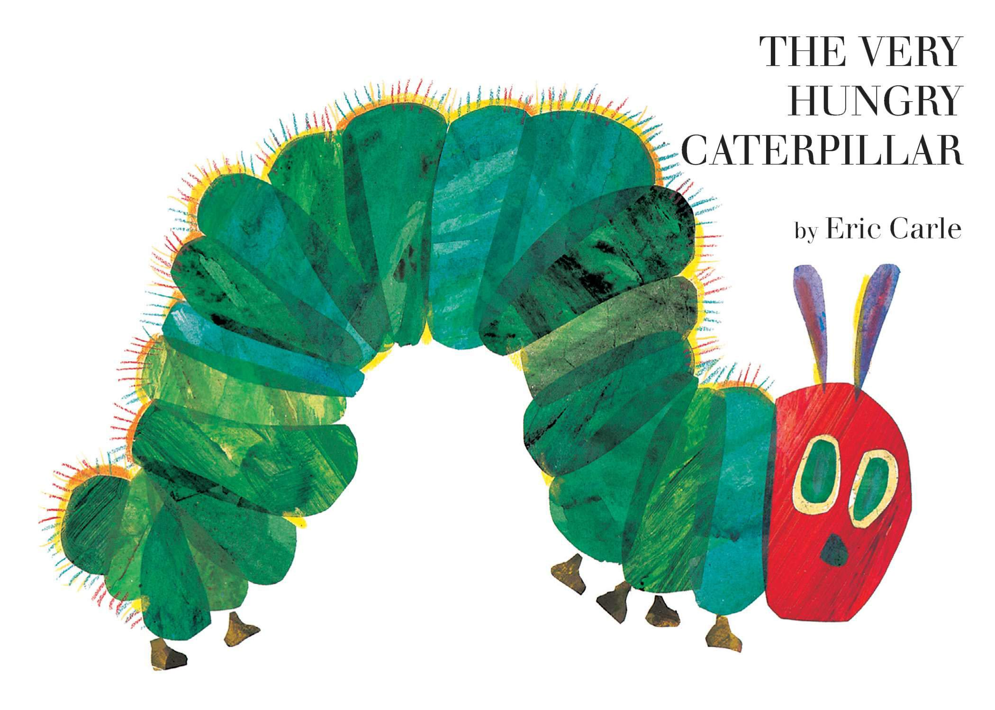

2. What do you think was the caterpillar’s favourite food?

I think the caterpillar’s favourite food was ________________________________________________.

I think this type of food was the caterpillar’s favourite because ______________________________________________________________________________________________________________________________________________________________________

Draw a picture of the caterpillar eating the food you chose in the space below.